Министерство образовании и науки Российской Федерации  
Федеральное государственное бюджетное образовательное учреждение высшего образования

«Белгородский государственный технологический университет им. В.Г. Шухова»

(БГТУ им. В.Г. Шухова)

Кафедра Программного обеспечения вычислительной техники

и автоматизированных систем

РГЗ  
по дисциплине: Компьютерная графика

***Создание трехмерного окружения с использованием OpenGL***

Выполнил: студент группы ПВ-41

Черенков Д. М.

Проверил: Осипов О.В.

Белгород 2017 г.

**Цель работы:** разработать изображение для визуализации трехмерных объектов внутри окружения с использованием OpenGL.

**Требования к программе**

1. Изобразить на сцене следующие объекты:
   1. Дом
   2. Объекты внутри дома (мебель)
   3. Окружение дома смоделировать по собственные усмотрения. Дверь растения, фонарь и т.д.
2. Поверхности должны иметь текстуры за исключением некоторых объектов
3. Обязательные элементы:
   1. Текстурирование
   2. Освещение
4. Предоставить возможность пользователю включать и выключать источники света (не менее 3).
5. Изобразить на сцене объекты из 6 и 7 лабораторных работ. Внутри дома, рядом с домом.
6. То, что не оговорено в задании, можно делать по собственному усмотрению.

**Скриншоты**

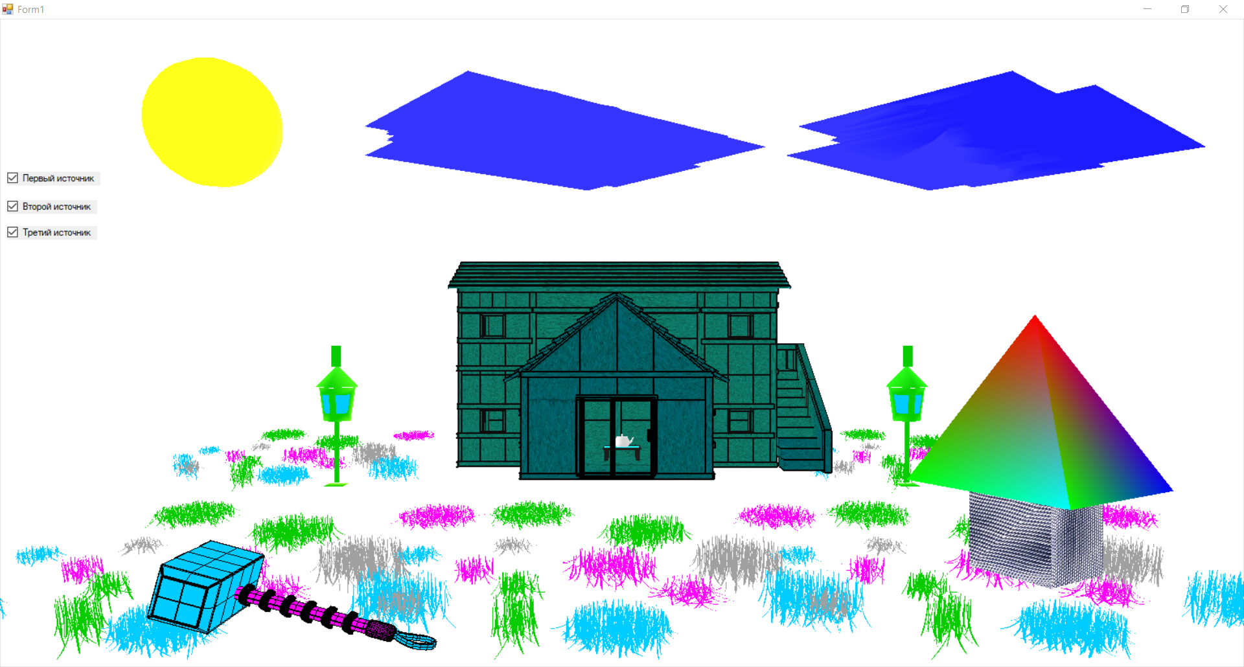

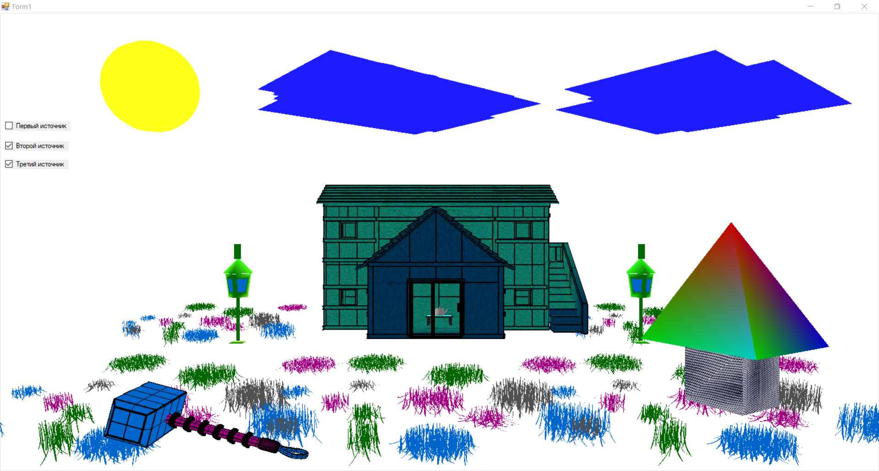

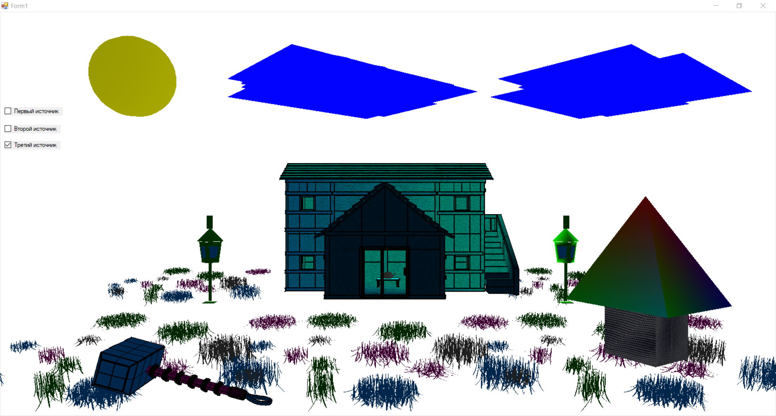

**Листинг программы**

**Form1.cs**

**using** System.Drawing;  
**using** System.Windows.Forms;  
**using** SharpGL;  
**using** SharpGL_RGZ.figures;  
  
**namespace** SharpGL_RGZ  
{  
 **public** partial **class** Form1 : Form  
 {  
 **public** Form1()  
 {  
 InitializeComponent();  
 }  
   
 **private readonly** FigureHouse _figureHouse = **new** FigureHouse();  
 **private readonly** FigureHummer _figureHummer = **new** FigureHummer();  
 **private readonly** FigureTable _figureTable = **new** FigureTable();  
 **private readonly** FigureDver _figureDver = **new** FigureDver();  
 **private readonly** FigureParallelepiped _figureParallelepiped = **new** FigureParallelepiped();  
 **private readonly** FigureTriangle _figureTriangle = **new** FigureTriangle();  
   
 **private** Point _currentLocation = **new** Point(0, 0);  
 **private float** _angleX;  
 **private float** _angleY;  
 **private float** z = -1f;  
  
 **private float**[] _black = {0f, 0f, 0f, 1f};  
   
 **private readonly** FigureSphere _figureSphere1 = **new** FigureSphere();  
 **private readonly** FigureSphere _figureSphere2 = **new** FigureSphere();  
 **private readonly** FigureSphere _figureSphere3 = **new** FigureSphere();  
  
 **private readonly** FigureFonar _figureFonar1 = **new** FigureFonar();  
 **private readonly** FigureFonar _figureFonar2 = **new** FigureFonar();  
  
 **private readonly** FigureTrava _figureTrava1 = **new** FigureTrava();  
 **private readonly** FigureCloud _figureCloud = **new** FigureCloud();  
   
 **private float**[] _l0pos = {-1.3f, 0.7f, -2.5f, 1.0f};  
 **private float**[] _l1pos = {-0.34f, -0.08f, -0.95f, 1.0f};  
 **private float**[] _l2pos = {0.34f, -0.08f, -0.95f, 1.0f};  
   
 **private float**[] _light0Scpecular = {1.0f, 1.0f, 1.0f, 1.0f};  
 **private float**[] _light0Ambient = {0.8f, 0.8f, 0.8f, 1f};  
 **private float**[] _light0Diffuse = {1f, 1f, 1f, 1f};  
   
 **private float**[] _light1Scpecular = {1f, 1f, 1f, 1f};  
 **private float**[] _light1Ambient = {0.5f, 0.5f, 0.5f, 1f};  
 **private float**[] _light1Diffuse = {0.6f, 0.6f, 0.6f, 0.6f};  
   
 **private float**[] _light2Scpecular = {0.1f, 0.1f, 0.1f, 0.5f};  
 **private float**[] _light2Ambient = {0.1f, 0.1f, 0.1f, 0.5f};  
 **private float**[] _light2Diffuse = {0.1f, 0.1f, 0.1f, 0.5f};  
   
   
 **private float**[] _sRef = {0.1f, 0.1f, 0.1f, 1.0f};  
  
 **public void** init()  
 {  
 _l2pos = **new**[] {0.34f + x1, -0.08f + y1, -0.95f + z1, 1.0f};  
 }  
   
 **private void** openGLControl1_OpenGLDraw(**object** sender, RenderEventArgs args)  
 {  
 init();  
 var gl = openGLControl1.OpenGL;  
   
 gl.Enable(OpenGL.GL_LIGHTING);  
*// gl.LightModel(OpenGL.GL_LIGHT_MODEL_AMBIENT, _black);* gl.Clear(OpenGL.GL_COLOR_BUFFER_BIT | OpenGL.GL_DEPTH_BUFFER_BIT);  
 gl.ClearColor(1f, 1f, 1f, 1f);  
   
 gl.Enable(OpenGL.GL_BLEND); *// Разрешить прозрачность.* gl.Enable(OpenGL.GL_POINT_SMOOTH); *// Разрешить сглаживание точек.* gl.Enable(OpenGL.GL_COLOR_MATERIAL); *// Отключить перелевание цвета.* gl.Enable(OpenGL.GL_TEXTURE_2D);  
 gl.PointSize(16); *// Размер точки.* gl.LineWidth(2); *// Толщина линий.* gl.LoadIdentity();  
 gl.Light(OpenGL.GL_LIGHT0, OpenGL.GL_POSITION, _l0pos);  
 _figureSphere1.Draw(gl, _l0pos[0], _l0pos[1], _l0pos[2], 0, 0, 2f, 0);  
 gl.LoadIdentity();  
   
 gl.Light(OpenGL.GL_LIGHT1, OpenGL.GL_POSITION, _l1pos);  
*// _figureSphere2.Draw(gl, _l1pos[0], _l1pos[1], _l1pos[2], 0, 0, 0.1f, 0);  
// gl.LoadIdentity();* _figureFonar1.Draw(gl, _l1pos[0] - 0.006f, _l1pos[1] - 0.1f, _l1pos[2], 0, 0, 0.03f, 0);  
 gl.LoadIdentity();  
  
 gl.Light(OpenGL.GL_LIGHT2, OpenGL.GL_POSITION, _l2pos);  
*// _figureSphere3.Draw(gl, _l2pos[0], _l2pos[1], _l2pos[2], 0, 0, 0.1f, 0);  
// gl.LoadIdentity();* _figureFonar2.Draw(gl, _l2pos[0] + 0.006f, _l2pos[1] - 0.1f, _l2pos[2], 0, 0, 0.03f, 0);  
 gl.LoadIdentity();  
   
 gl.LoadIdentity();  
 _figureCloud.Draw(gl, -0.5f, 1.5f, -5.55f);  
 gl.LoadIdentity();  
 _figureCloud.Draw(gl, 2.5f, 1.5f, -5.55f);  
   
   
 **if** (checkBox1.Checked)  
 {  
 gl.Enable(OpenGL.GL_LIGHT0);  
 }  
 **else** {  
 gl.Disable(OpenGL.GL_LIGHT0);   
 }  
  
 **if** (checkBox2.Checked)  
 {  
 gl.Enable(OpenGL.GL_LIGHT1);  
 }  
 **else** {  
 gl.Disable(OpenGL.GL_LIGHT1);   
 }  
  
 **if** (checkBox3.Checked)  
 {  
 gl.Enable(OpenGL.GL_LIGHT2);   
 }  
 **else** {  
 gl.Disable(OpenGL.GL_LIGHT2);   
 }  
   
 gl.LoadIdentity();  
 _figureHouse.Draw(gl, 0, 0, z, _angleX, _angleY, 1f, 0);  
 gl.LoadIdentity();  
 _figureTable.Draw(gl, 0, 0, z, _angleX, _angleY, 1f, 0);  
 gl.LoadIdentity();  
 _figureDver.Draw(gl, 0, 0, 0.16f + z, _angleX, _angleY, 1f, 0);  
 gl.LoadIdentity();  
 _figureParallelepiped.Draw(gl, 0.29f, -0.13f, -0.55f);  
 gl.LoadIdentity();  
 _figureTriangle.Draw(gl, 0.29f, -0.04f, -0.55f);   
 gl.LoadIdentity();  
 _figureHummer.Draw(gl, -0.29f, -0.17f, -0.55f);  
   
 gl.LoadIdentity();  
 _figureTrava1.Draw(gl, 0, -0.55f, z - 1f, _angleX, 0, 0.5f, 0);  
 gl.LoadIdentity();  
 _figureTrava1.Draw(gl, 1f, -0.55f, z - 1f, _angleX, 0, 0.5f, 0);  
 gl.LoadIdentity();  
 _figureTrava1.Draw(gl, -1f, -0.55f, z - 1f, _angleX, 0, 0.5f, 0);  
 gl.LoadIdentity();  
 _figureTrava1.Draw(gl, -1.6f, -0.55f, z - 3f, _angleX, 0, 0.5f, 0);  
 gl.LoadIdentity();  
 _figureTrava1.Draw(gl, 1.6f, -0.55f, z - 3f, _angleX, 0, 0.5f, 0);  
   
   
 gl.Light(OpenGL.GL_LIGHT0, OpenGL.GL_DIFFUSE, _light0Diffuse);  
 gl.Light(OpenGL.GL_LIGHT0, OpenGL.GL_AMBIENT, _light0Ambient);  
 gl.Light(OpenGL.GL_LIGHT0, OpenGL.GL_SPECULAR, _light0Scpecular);  
   
 gl.Light(OpenGL.GL_LIGHT1, OpenGL.GL_DIFFUSE, _light1Diffuse);  
 gl.Light(OpenGL.GL_LIGHT1, OpenGL.GL_AMBIENT, _light1Ambient);  
 gl.Light(OpenGL.GL_LIGHT1, OpenGL.GL_SPECULAR, _light1Scpecular);  
   
 gl.Light(OpenGL.GL_LIGHT2, OpenGL.GL_DIFFUSE, _light2Diffuse);  
 gl.Light(OpenGL.GL_LIGHT2, OpenGL.GL_AMBIENT, _light2Ambient);  
 gl.Light(OpenGL.GL_LIGHT2, OpenGL.GL_SPECULAR, _light2Scpecular);  
   
 gl.Color(0.5f, 0.5f, 0.5f);  
 gl.LoadIdentity();  
 gl.Translate(0, -0.125f, z);  
 var tea = **new** SharpGL.SceneGraph.Primitives.Teapot();  
 tea.Draw(gl, 14, 0.01, OpenGL.GL_FILL);  
   
   
 gl.ColorMaterial(OpenGL.GL_FRONT_AND_BACK, OpenGL.GL_AMBIENT_AND_DIFFUSE);  
 gl.Material(OpenGL.GL_FRONT_AND_BACK, OpenGL.GL_SPECULAR, _sRef);  
 gl.Material(OpenGL.GL_FRONT_AND_BACK, OpenGL.GL_SHININESS, 64);  
   
 gl.ShadeModel(OpenGL.GL_SMOOTH);  
 }  
   
 **private void** openGLControl1_MouseMove(**object** sender, MouseEventArgs e)  
 {  
 **if** (e.Button != MouseButtons.Left) **return**;  
 _angleY += (e.Location.X - _currentLocation.X) / 1.0f;  
 _angleX += (e.Location.Y - _currentLocation.Y) / 1.0f;  
 _currentLocation = e.Location;  
 }  
   
 **private void** openGLControl1_MouseDown(**object** sender, MouseEventArgs e)  
 {  
 **if** (e.Button != MouseButtons.Left) **return**;  
 _currentLocation = e.Location;  
 }  
   
 **protected override void** OnMouseWheel(MouseEventArgs e)  
 {  
 z += e.Delta > 0 ? 0.1f : -0.1f;  
 **base**.OnMouseWheel(e);  
 }  
   
 **private static float** x1 = 0;  
 **private static float** y1 = 0;  
   
 **private static float** x2 = 0;  
 **private static float** y2 = 0;  
   
 **private static float** x3 = 0;  
 **private static float** y3 = 0;  
   
 **private static float** z1 = 0;  
 **private static float** z2 = 0;  
   
 **private void** openGLControl1_KeyDown(**object** sender, KeyEventArgs e)  
 {   
 **switch** (e.KeyCode)  
 {  
 **case** Keys.Q:  
 **if** (e.Shift)  
 {  
 x1 += 0.01f;  
 }  
 **else** {  
 x1 -= 0.01f;  
 }  
 **break**;  
 **case** Keys.W:  
 **if** (e.Shift)  
 {  
 y1 += 0.01f;  
 }  
 **else** {  
 y1 -= 0.01f;  
 }  
 **break**;  
 **case** Keys.R:  
 **if** (e.Shift)  
 {  
 z1 += 0.01f;  
 }  
 **else** {  
 z1 -= 0.01f;  
 }  
 **break**;  
 }  
 }  
  
 }  
}

**FigureSphere.cs** (аналогичные классы: «FigureCloud», « FigureDver», « FigureFonar», «FigureHouse», « FigureHummer», « FigureSphere», « FigureTable», « FigureTrava»)

**using** System.Collections.Generic;  
**using** SharpGL;  
**using** SharpGL.SceneGraph.Assets;  
**using** SharpGL_6;  
**using** SharpGL_6.figures;  
  
**namespace** SharpGL_7.figures  
{  
 **public class** FigureHummer  
 {  
 **private readonly** List<Polygon> **_polygons**;  
  
 **public** FigureHummer()  
 {  
 **_polygons** = LoadPrimitive.Load(  
 **"C:\\Users\\User\\RiderProjects\\SharpGL_7\\SharpGL_7\\obj_files\\sphere.obj"**);  
 }  
  
 **private** Texture _texture = **new** Texture();  
  
 **public void** Draw(OpenGL gl, **float** ta, **float** ty, **float** tz, **float** angleX, **float** angleY, **float** scale, **float** z)  
 {  
*// _texture.Create(gl, "C:\\Users\\User\\RiderProjects\\SharpGL_7\\SharpGL_7\\files\\Eiche.bmp");* scale = 0.1f * scale;  
  
 gl.Translate(ta, ty, tz);  
 gl.Scale(scale, scale, scale);  
*// _texture.Bind(gl);* **foreach** (**var** polygon **in _polygons**)  
 {  
 gl.Begin(OpenGL.***GL_POLYGON***);  
 gl.Color(polygon.**color**.**R**, polygon.**color**.**G**, polygon.**color**.**B**);  
 **var** i = 0;  
 **foreach** (**var** points **in** polygon.**list**)  
 {  
*// gl.TexCoord(i == 0 || i == 1 ? 0f : 1f, i == 0 || i == 3 ? 0f : 1f);* gl.Vertex(points.**Item1**, points.**Item2**, points.**Item3**);  
 i += 1;  
 }  
 gl.End();  
 }  
*// _texture.Destroy(gl);* }  
 }  
}

**Polygon.cs**

**using** System;  
**using** System.Collections.Generic;  
**using** System.Drawing;  
  
**namespace** SharpGL_6  
{  
 **public class** Polygon  
 {  
 **public** Color **color**;  
 **public readonly** List<Tuple<**float**, **float**, **float**>> **list** = **new** List<Tuple<**float**, **float**, **float**>>();  
  
 **public** Polygon(Color color)  
 {  
 **this**.**color** = color;  
 }  
  
 **public void** AddPoint(Tuple<**float**, **float**, **float**> point)  
 {  
 **list**.Add(point);  
 }  
 **public void** AddPoint(**float** x, **float** y, **float** z)  
 {  
 AddPoint(**new** Tuple<**float**, **float**, **float**>(x, y, z));  
 }  
   
 }  
}

**LoadPrimitive.cs**

**using** System.Collections.Generic;  
**using** System.Drawing;  
**using** System.IO;  
**using** ObjLoader.Loader.Loaders;  
  
**namespace** SharpGL_6.figures  
{  
 **public static class** LoadPrimitive  
 {   
 **public static** List<Polygon> Load(**string** path)  
 {  
 **var** polygons = **new** List<Polygon>();  
   
 **var** objLoaderFactory = **new** ObjLoaderFactory();  
 **var** objLoader = objLoaderFactory.Create();  
 **var** fileStream = **new** FileStream(path, FileMode.***Open***);  
 **var** loadedObj = objLoader.Load(fileStream);  
  
 **var** colors = **new**[]  
 {  
 Color.FromArgb(255, 255, 128, 64),  
 Color.FromArgb(255, 5, 128, 0),  
 Color.FromArgb(255, 255, 0, 64),  
 Color.FromArgb(255, 200, 0, 160),  
 Color.FromArgb(255, 60, 0, 64),  
 Color.FromArgb(255, 0, 128, 255),  
 Color.FromArgb(255, 100, 100, 100),  
 Color.**Crimson** };  
 **var** k = -1;  
 **foreach** (**var** g **in** loadedObj.**Groups**)  
 {  
 k = (k + 1) % colors.**Length**;  
 **var** color = colors[k++];  
 **foreach** (**var** f **in** g.**Faces**)  
 {  
 **var** p = **new** Polygon(color);  
 **for** (**var** i = 0; i < f.**Count**; i++)  
 {  
 p.AddPoint(  
 loadedObj.**Vertices**[f[i].**VertexIndex** - 1].**X**,  
 loadedObj.**Vertices**[f[i].**VertexIndex** - 1].**Y**,  
 loadedObj.**Vertices**[f[i].**VertexIndex** - 1].**Z** );  
 }  
 polygons.Add(p);  
 }  
 }  
  
 fileStream.Close();  
 **return** polygons;  
 }  
 }  
}

**FigureParallelepiped.cs**

**using** SharpGL;  
**using** SharpGL.SceneGraph.Assets;  
  
**namespace** SharpGL_RGZ.figures  
{  
 **public class** FigureParallelepiped  
 {  
 **private float a** = 1, **b** = 1, **c** = 1;  
  
 **public** FigureParallelepiped(**float** a, **float** b, **float** c)  
 {  
 **this**.**a** = a;  
 **this**.**b** = b;  
 **this**.**c** = c;  
 }  
  
 **public** FigureParallelepiped()  
 {  
 }  
   
 **private** Texture **_texture** = **new** Texture();  
   
 **public void** Draw(OpenGL gl, **float** ta, **float** ty, **float** tz)  
 {  
 **_texture**.Create(gl, **"C:\\Users\\User\\RiderProjects\\SharpGL_7\\SharpGL_7\\files\\12387996.jpg"**);  
 **var** scale = 0.06f * 1;  
   
 gl.Translate(ta, ty, tz);  
 gl.Rotate(30, 0, 1f, 0);  
*// gl.LookAt(0, 0, z, 0, 0, z + 10, 0 , 1, 0);* gl.Scale(scale, scale, scale);  
  
 gl.Normal(0f, 0f, 1f);  
 gl.Begin(OpenGL.***GL_QUAD_STRIP***);  
 gl.Color(1f, 1f, 1f);   
 **_texture**.Bind(gl);  
 gl.TexCoord(0f, 0f); gl.Vertex(-**a** / 2, -**b** / 2, -**c** / 2);  
 gl.TexCoord(1f, 0f); gl.Vertex(-**a** / 2, -**b** / 2, **c** / 2);  
 gl.TexCoord(1f, 1f); gl.Vertex(-**a** / 2, **b** / 2, -**c** / 2);  
 gl.TexCoord(0f, 1f); gl.Vertex(-**a** / 2, **b** / 2, **c** / 2);  
  
 gl.TexCoord(0f, 0f); gl.Vertex(**a** / 2, **b** / 2, -**c** / 2);  
 gl.TexCoord(1f, 0f); gl.Vertex(**a** / 2, **b** / 2, **c** / 2);  
 gl.TexCoord(1f, 1f);  
 gl.TexCoord(0f, 1f);  
  
 gl.TexCoord(0f, 0f);   
 gl.TexCoord(1f, 0f); gl.Vertex(**a** / 2, -**b** / 2, -**c** / 2);  
 gl.TexCoord(1f, 1f); gl.Vertex(**a** / 2, -**b** / 2, **c** / 2);  
 gl.TexCoord(0f, 1f);   
   
 gl.TexCoord(0f, 0f);   
 gl.TexCoord(1f, 0f);   
 gl.TexCoord(1f, 1f); gl.Vertex(-**a** / 2, -**b** / 2, -**c** / 2);  
 gl.TexCoord(0f, 1f); gl.Vertex(-**a** / 2, -**b** / 2, **c** / 2);  
 gl.End();   
  
 gl.Begin(OpenGL.***GL_QUADS***);  
  
 gl.TexCoord(0f, 0f); gl.Vertex(-**a** / 2, -**b** / 2, **c** / 2);  
 gl.TexCoord(1f, 0f); gl.Vertex(-**a** / 2, **b** / 2, **c** / 2);  
 gl.TexCoord(1f, 1f); gl.Vertex(**a** / 2, **b** / 2, **c** / 2);  
 gl.TexCoord(0f, 1f); gl.Vertex(**a** / 2, -**b** / 2, **c** / 2);  
  
 gl.TexCoord(0f, 0f); gl.Vertex(-**a** / 2, -**b** / 2, -**c** / 2);  
 gl.TexCoord(1f, 0f); gl.Vertex(-**a** / 2, **b** / 2, -**c** / 2);  
 gl.TexCoord(1f, 1f); gl.Vertex(**a** / 2, **b** / 2, -**c** / 2);  
 gl.TexCoord(0f, 1f); gl.Vertex(**a** / 2, -**b** / 2, -**c** / 2);  
   
  
 gl.End();  
 **_texture**.Destroy(gl);  
 }  
   
 }  
}

**FigureTriangle.cs**

**using** SharpGL;  
  
**namespace** SharpGL_RGZ.figures  
{  
 **public class** FigureTriangle  
 {  
 **public void** Draw(OpenGL gl, **float** ta, **float** ty, **float** tz)  
 {  
 **var** scale = 0.06f * 1f;  
  
 gl.Translate(ta, ty, tz);  
 gl.Rotate(30, 0, 1f, 0);  
 gl.Scale(scale, scale, scale);  
 gl.Begin(OpenGL.***GL_TRIANGLES***);  
  
 gl.Color(1f, 0, 0);  
 gl.Vertex(0.0f, 1.0f, 0f);  
 gl.Color(0, 1f, 0);  
 gl.Vertex(-1.0f, -1.0f, 1.0f);  
 gl.Color(0, 0, 1f);  
 gl.Vertex(1.0f, -1.0f, 1.0f);  
  
 gl.Color(1f, 0, 0);  
 gl.Vertex(0.0f, 1.0f, 0f);  
 gl.Color(0, 0, 1f);  
 gl.Vertex(1.0f, -1.0f, 1.0f);  
 gl.Color(0, 1f, 0);  
 gl.Vertex(1.0f, -1.0f, -1.0f);  
  
 gl.Color(1f, 0, 0);  
 gl.Vertex(0.0f, 1.0f, 0f);  
 gl.Color(0, 1f, 0);  
 gl.Vertex(1.0f, -1.0f, -1.0f);  
 gl.Color(0, 0, 1f);  
 gl.Vertex(-1.0f, -1.0f, -1.0f);  
  
 gl.Color(1f, 0, 0);  
 gl.Vertex(0.0f, 1.0f, 0f);  
 gl.Color(0, 1f, 0);  
 gl.Vertex(-1.0f, -1.0f, -1.0f);  
 gl.Color(0, 1f, 1f);  
 gl.Vertex(-1.0f, -1.0f, 1.0f);  
  
 gl.End();  
  
 gl.Begin(OpenGL.***GL_QUADS***);  
 gl.Color(1f, 0, 0);  
 gl.Vertex(-1.0f, -1.0f, -1.0f);  
 gl.Color(0, 1f, 0);  
 gl.Vertex(-1.0f, -1.0f, 1.0f);  
 gl.Color(0, 1f, 1f);  
 gl.Vertex(1.0f, -1.0f, 1.0f);  
 gl.Color(0, 1f, 1f);  
 gl.Vertex(1.0f, -1.0f, -1.0f);  
 gl.End();  
 }  
 }  
}

**LoadPrimitive.cs**

**using** System.Collections.Generic;  
**using** System.Drawing;  
**using** System.IO;  
**using** ObjLoader.Loader.Loaders;  
  
**namespace** SharpGL_RGZ.figures  
{  
 **public static class** LoadPrimitive  
 {   
 **public static** List<Polygon> Load(**string** path)  
 {  
 **var** polygons = **new** List<Polygon>();  
   
 **var** objLoaderFactory = **new** ObjLoaderFactory();  
 **var** objLoader = objLoaderFactory.Create();  
 **var** fileStream = **new** FileStream(path, FileMode.***Open***);  
 **var** loadedObj = objLoader.Load(fileStream);  
  
 **var** colors = **new**[]  
 {  
 Color.FromArgb(255, 0, 128, 255),  
 Color.FromArgb(255, 255, 215, 0),  
 Color.FromArgb(255, 5, 128, 0),  
 Color.FromArgb(255, 255, 0, 64),  
 Color.FromArgb(255, 200, 0, 160),  
 Color.FromArgb(255, 60, 0, 64),  
 Color.FromArgb(255, 100, 100, 100),  
 Color.Crimson  
 };  
 **var** k = -1;  
 **foreach** (**var** g **in** loadedObj.**Groups**)  
 {  
 k = (k + 1) % colors.**Length**;  
 **var** color = colors[k++];  
 **foreach** (**var** f **in** g.**Faces**)  
 {  
 **var** p = **new** Polygon(color);  
 **for** (**var** i = 0; i < f.**Count**; i++)  
 {  
 p.AddPoint(  
 loadedObj.**Vertices**[f[i].**VertexIndex** - 1].**X**,  
 loadedObj.**Vertices**[f[i].**VertexIndex** - 1].**Y**,  
 loadedObj.**Vertices**[f[i].**VertexIndex** - 1].**Z** );  
 }  
  
 polygons.Add(p);  
 }  
 }  
  
 fileStream.Close();  
 **return** polygons;  
 }  
 }  
}

**LoadPrimitive.cs**

**using** System;  
**using** System.Collections.Generic;  
**using** System.Drawing;  
  
**namespace** SharpGL_RGZ.figures  
{  
 **public class** Polygon  
 {  
 **public** Color **color**;  
 **public readonly** List<Tuple<**float**, **float**, **float**>> **list** = **new** List<Tuple<**float**, **float**, **float**>>();  
  
 **public** Polygon(Color color)  
 {  
 **this**.**color** = color;  
 }  
  
 **public void** AddPoint(Tuple<**float**, **float**, **float**> point)  
 {  
 **list**.Add(point);  
 }  
   
 **public void** AddPoint(**float** x, **float** y, **float** z)  
 {  
 AddPoint(**new** Tuple<**float**, **float**, **float**>(x, y, z));  
 }  
   
 }  
}